Employee management system

Here is represented how endpoints work via Postman.

Firstly, we are making new employee by sending POST JSON body with name, department, joinDate fields. Id is auto generated so there is no need to add it to request.

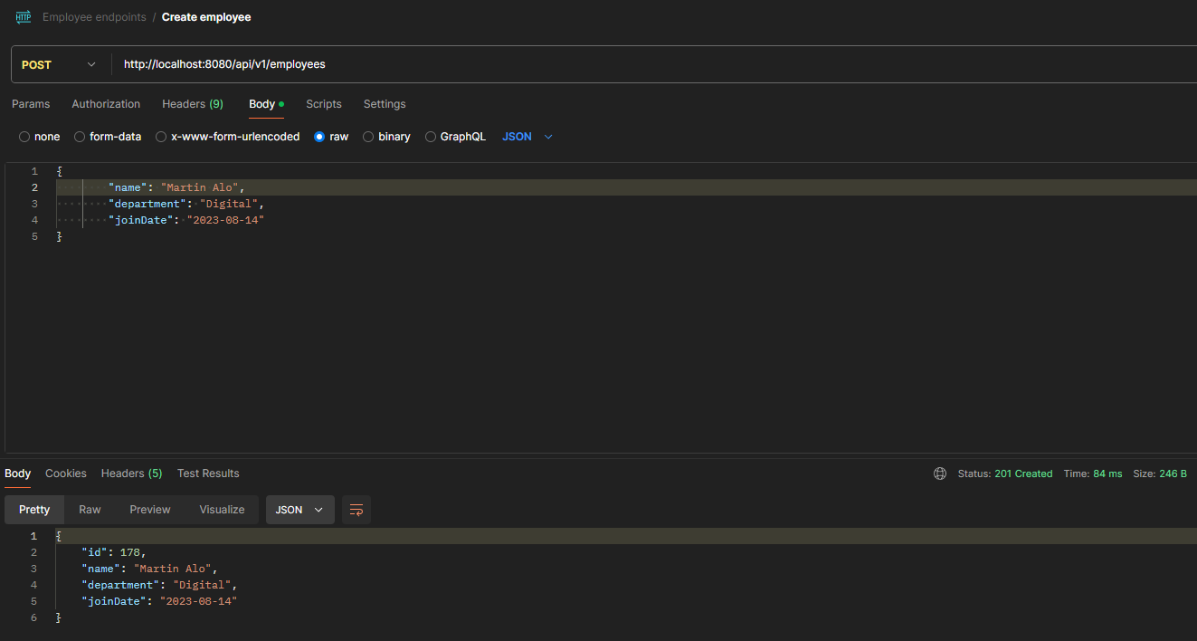

Pic.1

By using get all employees endpoint we see that now our new employee is added with id 178. Another employees were added in background for better showcase.

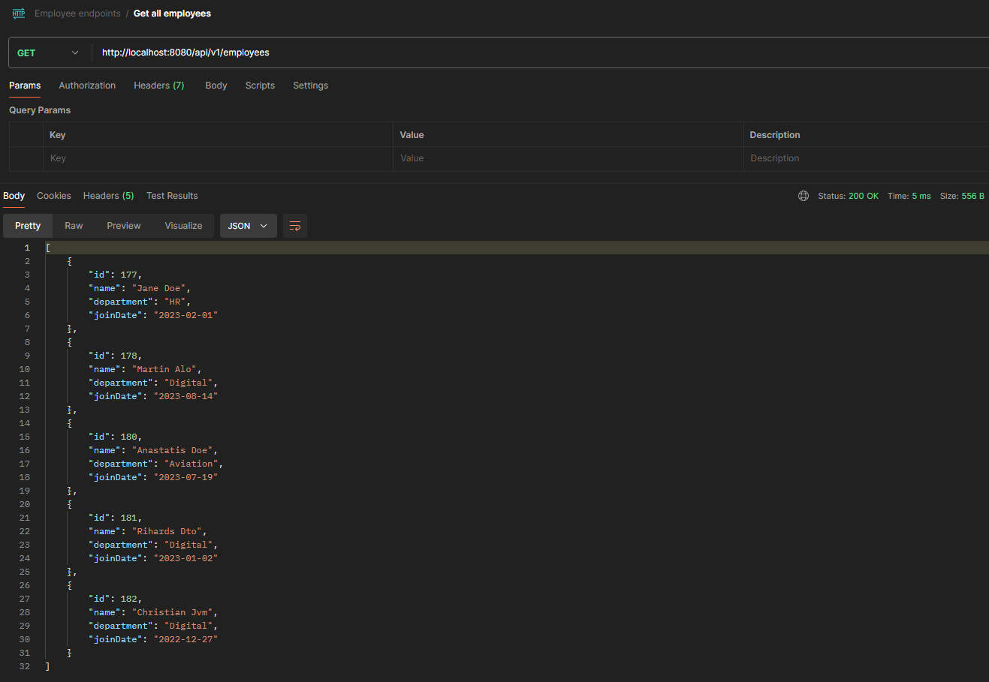

Pic.2

Now we are trying to export filtered employees by Digital department and who joined after 2023.01.01. We are pushing these 2 parameters. From the Pic.2 we see that we should get only 2 employees.

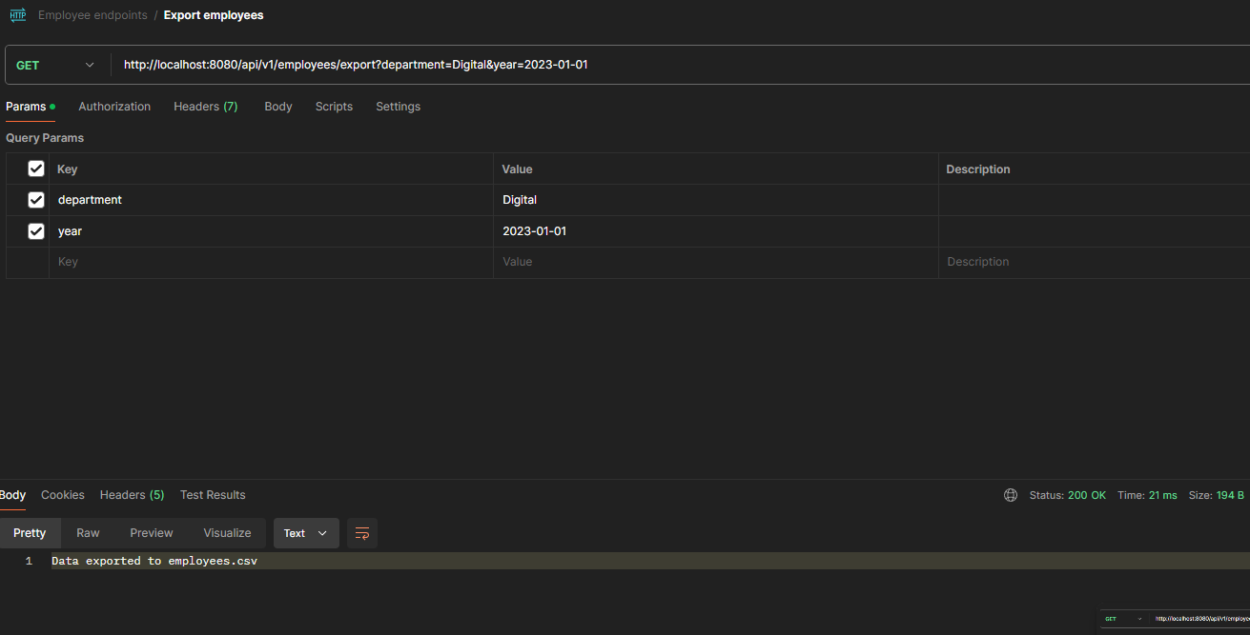

Pic.3

And yes in a generated file “employees.csv” we have 2 employees.

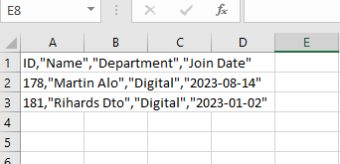

Pic.4

Delete endpoint works in a straightforward way. By pushing employee ID as a path variable we will receive message that employee was deleted, or employee id does not exist.

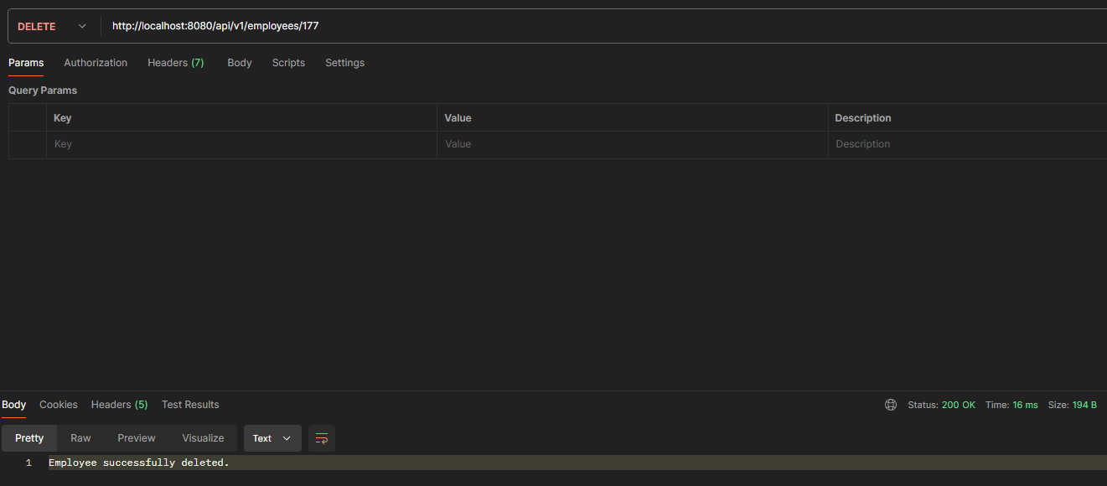

Pic.5

Now if we check all employees – id 177 employee does not exist.

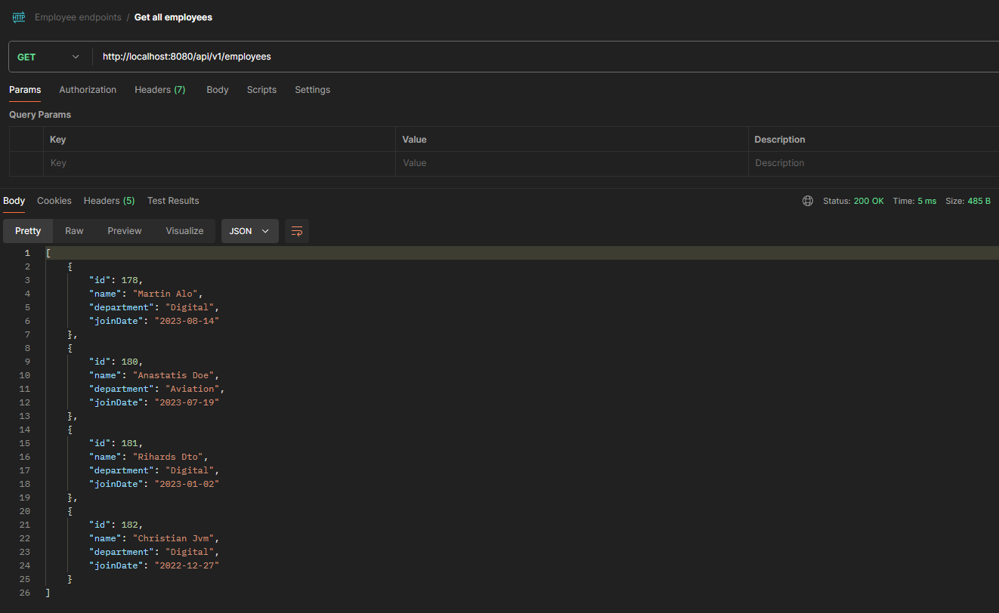

Pic.6